22. Write a C program to Graph traversal using Depth First Search

**Aim:** To write a C program that performs **Depth First Search (DFS)** traversal of a graph.

* The program should accept a graph (using adjacency matrix or adjacency list).
* It should accept a starting vertex.
* It should traverse (visit) vertices reachable from that start using DFS.

**Algorithm:**

1. Declare an array visited[0..V-1], initialized to FALSE for all vertices.

2. Define recursive procedure DFS(vertex v):

visited[v] ← TRUE

print v

for each u from 0 to V-1 do

if G[v][u] == 1 AND visited[u] == FALSE then

DFS(u)

end if

end for

3. In main:

Read V

Read edges (fill adjacency matrix)

Read start vertex

Call DFS(start)

**Program:**

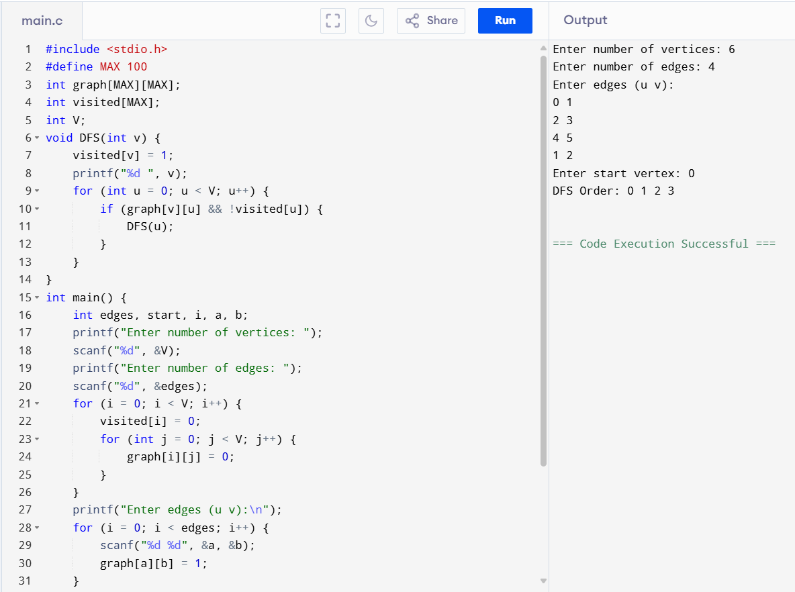

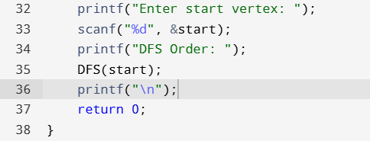

**Result:** The program has executed successfully and the output is verified.